**Easy Way to Create Your Amazing Portfolio Output**

**Signup Page**

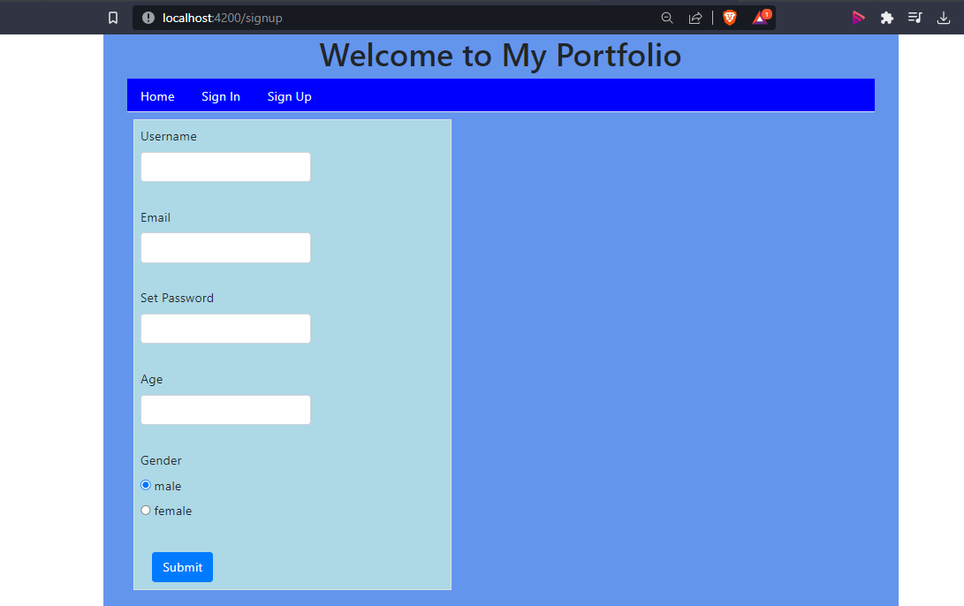

**Sign In page**

